Initial Installation

Prerequisites Applications:
- Git
- WSL
- Docker Desktop
- MySQL (Docker Installation)
- Helm
- Keycloak (Docker Installation)
- Kafka (Docker installation)

Steps to follow:
- Install Git
- Install WSL
- Install Docker Desktop
- Setup Directory for assets
- Run Docker Compose to Install utilities
- Keycloak Configuration Steps
- Run Helm Project and verify everything is working properly

- Install Git

- Install WSL
- wsl --install
- wsl --update
- wsl --version

  - Install Docker Desktop
3.2 Setup Directory for assets
- Go to Docker Desktop
- Go to Settings > Resources > File Sharing
- Add local directory: C:\storageMACC
  - 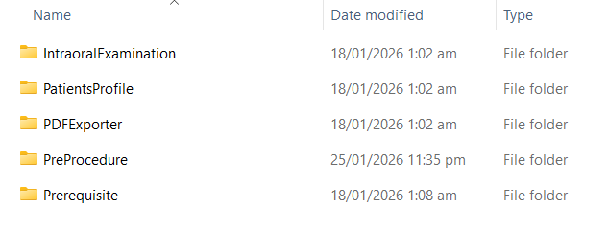

2.1 Run Docker Compose to Install utilities:
- Docker compose -p docmaccdentalclinic-utility -d up
- MySQL Server
  - Auto creation of database schema:
- Docmaccdbdentaluser
- Docmaccdbpatient
- Docmaccdbmedical
- Docmaccdbdentalchart
- Docmaccdbtreatmentplan
- Docmaccdbbill
- Auto max connection by default to 200
- show variables like 'max_connections';
- show processlist;
- SHOW STATUS LIKE 'Threads_connected';
- Root admin password: d0cM@CCdbAkc3s!69
- Keycloak
- Kafka
- Zipkin

**Note: Before executing command above do the following:
- Update database username and password
- Update location of custom login
- Check location of Keycloak themes
- Dir’s:
  - /Users/arwinsison/Webdev/LaunchApp/k8s_MACC/customLogin
  - C:\Users\Kenneth\Projects\DentalWeb\Frontend\customLogin
- Verify on docker is themes is added or configured
- Admin account: username: admind0cmacc, password: adm!nM@Ccv1s3cr3t

3. Keycloak Configuration Steps
- Access URL: http://localhost:7080/admin
- Create realm
  - Browse the json realm file to be imported
- Create user (change to doc users)
  - Email verified: yes
  - Username: kenmac17
  - Email: test.email@email.com
  - First name: Kenneth
  - Last name: Macaraeg
  - Credentials
    - Set password : admin123 (toChange)
    - Temporary: false
- Assign role of users from client roles
  - Go to User (kenmac17)
    - Click Role mapping tab
    - Click Assign role button
    - Filter by clients
    - Search role you created: ADMIN / SECRETARY / USER
    - Click Assign

4. Run Helm Project
- helm install macc-v1 .
- kubectl get all -o wide
- kubectl pods <logs> --tail 200

